Class III Maths – 20th July 2019; Saturday:
3. Write the names of these shapes and mention how many sides does each figure have?

i. ii. iii. iv.
Shape = ____________ ________ ____________ ____________
No. of Sides= ________ ________ ____________ ____________
4. Complete the following series:
i. 999, _______, _________, 996, _______, ________ 993
ii. 100, _______, 200, _______, ________, 350, _______, 450
5. How many odd numbers are there between 10 and 30? a. 11 ( ) b. 10 ( ) c. 15 ( ) d. 13 ( )
6. 879= 8 hundreds + 7 tens + _________ ones:
a. 11 ( ) b. 10 ( ) c. 9 ( ) d. 7 ( )
****************************************************************
Class IV Maths – 20th July 2019; Saturday:
3. How many days in all in 2019 and 2020? _______________ days.
4. What is the missing number in the box?
26 | 17 | 17 | 17
? |  | 34
77
a. 51 [ ] b. 17 [ ] c. 43 [ ] d. 34 [ ]

5. Which of the following is same as 125 seconds?
a. 2 minutes 5 seconds [ ] b. 1 minute 5 seconds [ ]
c. 2 hours 5 seconds. [ ] d. 12 minutes 5 seconds [ ]

6. My aunt brought 25 packets of balloons. Each packet has 4 balloons. Which among the following represents the total number of balloons brought by my aunt?
a. 25--4 [ ] b. 25 x 4 [ ] c. 25 + 4 [ ] d. 25 / 4 [ ]
*****************************************************************************
Class V Maths – 20th July 2019; Saturday:
1. Look at the four magazine covers. The numeral below each magazine indicates the total number of copies sold in a month? Which among the following statements is FALSE?
i. ii. iii. 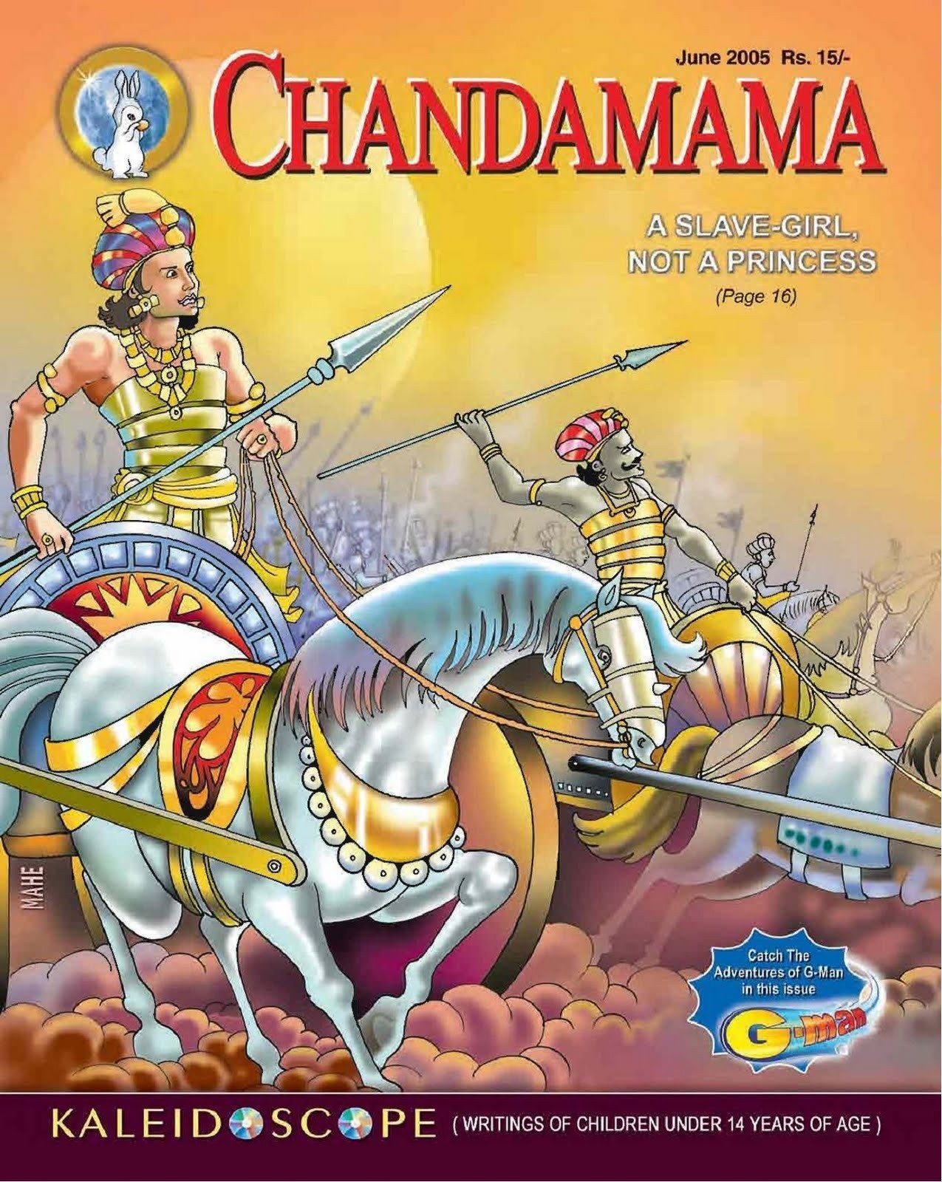 iv
12, 555 22,600 18, 897 23,999

a. Wee Wisdom is the LEAST sold per month among all the four magazines ( )
b.. The sale of National Geographic Kids and Magic Pot is more than 22, 000 per month ( )
c. Ascending order of sales: Wee Wisdom < Chandamama < Magic Pot < NG Little Kids. ( )
d.. All the four magazines are equally sold in the market.. ( )
2. How many straight lines are required to make a octagon? a. 5 [ ] b. 4 [ ] c. 8 [ ] d. 6 [ ]
3. Which among the following figures has four right angles (90 degrees)?
a. Circle [ ] b. Semi Circle [ ] c. A triangle with each of its angles=60 degrees [ ] d. A Square [ ]
4. Find the greatest 5 digit ODD number formed using digits 3, 9, 4, 8, 5
a. 98543 [ ] b. 84359 [ ] c. 58439 [ ] d. 89543 [ ]
*********************************************************************************************************.
Class VI Maths – 20th July 2019; Saturday:
1. 9th January 2019 was a Wednesday. What day will be 9th March of the same year?
a. Thursday [ ] b. Friday [ ] c. Saturday [ ] d. Sunday [ ]

2. Which of the following is the product of 1¹/_{3,} 3¹/_{4,} and ⁷/₈
a. 3⁵/₂₄ [ ] b. 3¹⁹/₂₄ [ ] c. 3¹/₂₄ [ ] d. 19³/₇ [ ]

3. Here are a few Roman numerals: I, C, L, M, D Which of the following number can be written using all the above given Roman numerals?
a.1775 [ ] b. 864 [ ] c. 1947 [ ] d. 1753 [ ]

4. Look at this figure. What’s the area of the shaded region if each SQUARE is 4cm x 4 cm?

4cm

a. 300 cm² [ ] b. 212 cm² [ ] c. 200 cm² [ ] d. 288cm² [ ]
**********************************************************************************************************
Class VII Maths – 20th July 2019; Saturday:
1. Saurabh has a story book issued from his School Library. The book has 200 pages and he has to return the book in a week. What should he know to find out in order to finish reading the book in a week?
a. the number of books in the library [ ]
b.the number of chapters in the book [ ]
c. the number of pages that he can read the most in a day [ ]
d. the number of people who have read the book [ ]
2. Which of these numbers when subtracted from 100 will give the answer that is greater than 40? a. 47 [ ] b. 60 [ ] c. 76 [ ] d. 85 [ ]
3. 8 times 2424 is the same as 4 times ____________.
a. 606 [ ] b. 1212 [ ] c. 4848 [ ] d. 9696 [ ]
4. Krishna thinks of a number; divides it by 3 and then adds 15. He gets 45 as the result.
What was the number that Krishna had thought of?
a. 10 [ ] b. 30 [ ] c. 90 [ ] d. 180 [ ]
*****************************************************************************
Class VIII Maths – 20th July 2019; Saturday:
1. Which among the following are not perfect squares?
a. 625 [ ] b. 100 [ ] c. 1000 [ ] d. 169 [ ]

2. Rohan made a schedule to manage his after-school time from 4 p.m. to 8 p.m. shown as follows : STUDY – 2 hours ; SPORTS – 1.5 hours He wants to spend the remaining time watching TV. How long can he watch TV between 4 p.m. to 8 p.m.?
a. 30 minutes [ ] b. 50 minutes [ ] c. 110 minutes [ ] d. 150 minutes [ ]

3. Aradhya picked up two different numbers from a set of number cards. 300 is a multiple of both the numbers. Which of these CANNOT be a number she picked?
a. 45 [ ] b. 50 [ ] c. 60 [ ] d. 75 [ ]

4. Which of these is same as ³⁷/₁₂ ?
a. 20 ⁷/₁₂ [ ] b. 9 ¹/₄ [ ] c. 2 ⁷ / ₁₂ [ ] d. 2 ¹/₄ [ ]
********************************************************************************************
Class IX Maths – 20th July 2019; Saturday:
1. Today is Varun's birthday. One year, from today he will be twice as old as he was 12 years ago. How old is Varun today?

a. 20 years [ ] b. 22 years [ ] c. 25 years [ ] d. 27 years [ ]
2 Ayush was born two years after his father's marriage. His mother is five years younger than his father but 20 years older than Ayush who is 10 years old. At what age did the father get married?

a. 23 years [ ] b 25 years [ ] c. 33 years [ ] d. 35 years [ ]

3. The sum of three consecutive multiples of 3 is 72. What is the second largest number?
a. 27 [ ] b 21 [ ] c. 24 [ ] d. 42 [ ]

4. In a class of 60 students, the number of boys and girls participating in the annual sports is in the ratio 3:2 respectively. The number of girls not participating in the sports is 5 more than the number of boys not participating in the sports. If the number of boys participating in the sports is 15, then how many girls are there in the class?
a. 20 [ ] b 25 [ ] c. 30 [ ] d. 45 [ ]
*********************************************************************************
Class X Maths – 20th July 2019; Saturday:
1. A shopkeeper buys a number of books for Rs 80/- If he had bought 4 more books for the same amount each book would have cost 1 rupee less. How many books did he buy?
a. 16 [ ] b. 20 [ ] c. 18 [ ] d. 22 [ ]
2. A shopkeeper sold an air conditioner for Rs. 25935 with a discount of 9% and earned a profit of 3.74% what would have been the percentage profit if no discount were offered?
a. 12.3% [ ] b. 15.6% [ ] c. 16% [ ] d. none of these [ ]

3. Which among the following numbers is not a perfect square?
a. 15625 [ ] b. 48841 [ ] c. 325 [ ] d. 360000 [ ]
4. Supply the missing numeral in the series 669, 678, 796, ________ , 896
a. 779 [ ] b. 824 [ ] c. 832 [ ] d. 800 [ ]
*******************************************************************************
Class XI Maths – 20th July 2019; Saturday:
1. Read carefully and fill in the blanks with the appropriate terminology
The axes of a two-dimensional Cartesian system divides the plane into four infinite regions called as _________________ each bounded by two half axes. These are often numbered in Roman numerals [ I, II, III, IV] where the signs of ‘x’ and ‘y’ _________________ are
I ( +, +) ; II (-, +) ; III ( -, - ) and IV ( + , -)
i. Horizontal, Vertical [ ] ii. Quadrants, Co-ordinates [ ]
iii.Vertical, Horizontal [ ] iv. Co-ordinates and Quadrants [ ]
2. Which will fetch us more amount on a fixed capital ‘P’ deposited in the bank for 5 years at
the rate of interest applicable on that date?
i. Prt / 100 [ ] ii. P + SI [ ] iii. P x[1 + r / 100]^{n} [ ] iv. P + R+ t / 100 [ ]
3. Draw a cube and label the points A, B, C, D, E, F, G & H
i. What are AB, BC, CD & AD of the cube ? _______
ii. What are the points A, B, C, D, E, F, G & H called? ______
4. Name the faces of the aforesaid cube. __________________________________________
*******************************************************************************
Class XII Maths – 20th July 2019; Saturday:
1. A passage 12 m long, 3 m high and 4 m wide has two doors of 2.5 by 1.5 m and a window of 2 m by 0.6 m. The cost of colouring the walls and ceiling @ Rs. 15 per sq. metre will be?
i. Rs. 1023 [ ] ii. Rs. 432 [ ] iii. Rs. 2029.5 [ ] iv Rs. 1635 [ ]
2. The surface areas of the three continuous faces of a cuboid are 6, 15 and 10 sq. cm respectively. The volume of the cuboid will be
i. 30 c.c. [ ] ii. 20 c.c. [ ] iii. 40 c.c [ ] iv. 35 cc. [ ]

3. Which among the following is not a perfect square?
i. 15625 [ ] ii. 4884 [ ] iii. 325 [ ] iv. 360000 [ ]

4. Supply the missing numeral in the series
144, 169, _______, ________256, 289, _________, 361.
********************************************************************

